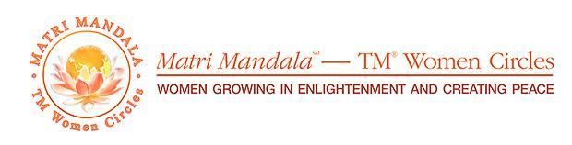

*You’re Invited  
Ashburn Matri Mandala–TM Women Circles*  
***Sunday, December 15, 2024  
3 pm Eastern*** *(correct for your time zone)  
or Tuesday, December 17, 2024, 1 pm Eastern****At the home of… or at your city’s TM Center*** *(address)****Host:*** *(your name)****RSVP:***  *(your email address)*

***Theme: Women Coming Together Around the World,  
Growing in Enlightenment and Creating Peace – Focus on Uganda*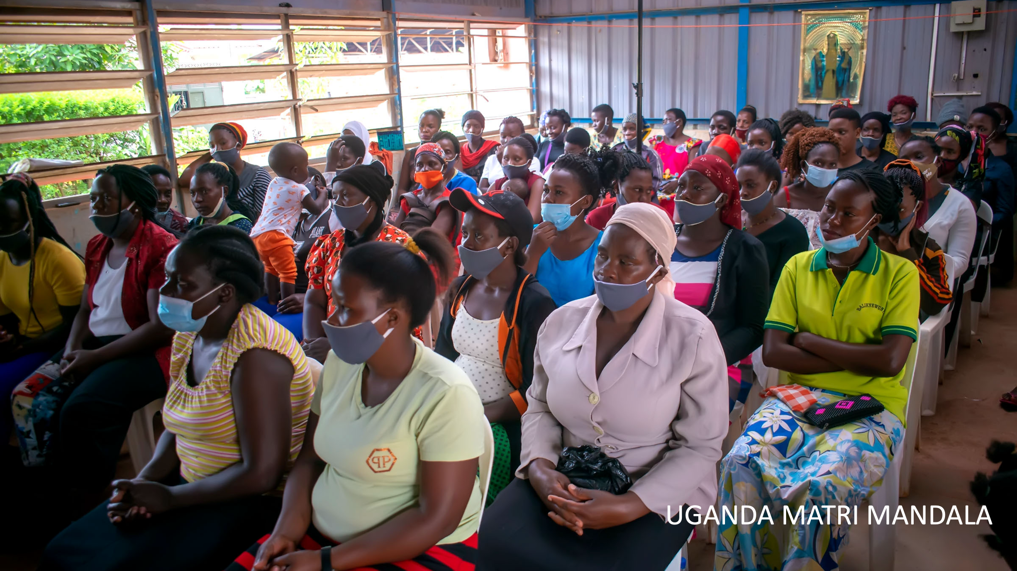**Thousands of women in Uganda are joining the worldwide community of women who practice the Transcendental Meditation technique. Join Judith Nassali and her team of dynamic women TM teachers and hear how life in Uganda is being transformed through the power of consciousness.

Matri Mandalas are groups of women gathering around the world every three months to deepen their experience and knowledge of consciousness, enjoy the nourishing power of women being together, make new friends, and be in the soft bliss of the Mother Divine Program.  
  
Format of the one-hour webinar (in-person and online): Knowledge presentation, Q&A, Group Meditation, Song from Mother Divine  
  
Refreshments: Those who wish to bring refreshments to share are welcome to do so. Contact (your name and email address)